Ah Xian
‘Metaphysica’
Activity
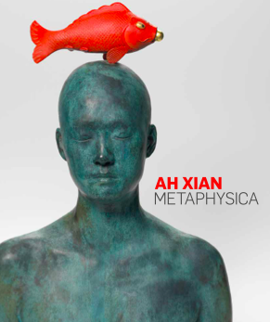
Create a portrait of yourself or a person you admire and reflect on aspects of them that capture your imagination. Using Ah Xians Metaphysica concept, choose an object to help represent this person.

Throughout your art practice consider the following;

• What is your heritage?

• What does this mean to you?

• What are some traditional art forms specific to your culture and heritage?

• How could these be reinterpreted in contemporary culture?

• What symbols or metaphors do you associate them with?

• What symbolic objects does this person love, appreciate or enjoy?

• Are there any cultural motifs you can include that are related to the person’s heritage?

• Is there a particular artistic technique that corresponds with the person’s heritage, interests or background?

• Think about colour and texture, and how these might affect meaning.

• Choose a medium (plaster, resin, pen and ink, watercolour, or found objects) to represent the person.

Please, make sure all of your process is documented in your VAPD for submission.

